Digital Technologies & Hangarau Matihiko 3.1

Level 3, 3 Credits, Internal Assessment

Student Documentation

This document serves as evidence of your work for **AS 91901: Apply user experience methodologies to develop a design for a digital technologies outcome**

# Instructions

Edit the header and replace the underlines with your full name and NSN (you can find this on PCSchools under Student Information).

You must attach relevant images (wireframes, mockups, screenshots, etc.) into each section of the document. You must also include a high-resolution copy of these images separately.

For your **FINAL** submission, make sure you have included:

1. Your name and National Student Number (NSN) in the header for each page
2. **ONLY** include the information you wish to have marked and moderated

Table of Contents

Instructions 1

Explain the purpose of the digital technologies outcome and the requirements of the end users 2

Explain relevant implications 5

Investigate relevant user experience methodologies 7

Iteration #1 8

Iteration #2 11

Iteration #3 14

Explain the appropriateness of a chosen design 17

Evaluate how the design addresses relevant implications 18

Justify that the chosen design is suitable for the purpose and end users 20

Justify how the chosen design might be further developed in the future 20

Appendix 21

# Explain the purpose of the digital technologies outcome and the requirements of the end users

## Purpose

Write the communicative purpose of the outcome in the field below.

|  |
| --- |
| The purpose of the website is to educate viewers on Onslow College’s cultural history. To achieve this, I will be creating a quiz site, which will allow the users to better learn and memorize said history. I will also need to implement classes that teacher accounts will be able to assign to student accounts. |

## Identify stakeholders

You need to identify your end users. Fill in the table below with the end users you have identified, including whether that person/group is a primary stakeholder (usually the project owner), secondary stakeholder, and/or end-users.

|  |  |
| --- | --- |
| **Individual/group name** | **Role (i.e. end user, stakeholder, owner, etc.)** |
| Onslow students (Y9-Y13) | Primary end users (Using site to educate self) |
| Onslow teachers | Secondary stakeholder (Utilizing site to educate others) |
| Local Whānau | Secondary end users (Also using site to educate self) |
| Other Onslow Staff | Secondary end users (Also using site to educate self) |
| Jayden Everest | Primary stakeholder (Project owner) |

## Stakeholder requirements

Identify the stakeholder’s requirements through surveys, interviews, and usability testing.

Write a list or paragraph for each subheading.

## Functionality

-

## Design (visuals)

-

## Data

-

## Technological

-

## Budget

-

# Explain relevant implications

What relevant implications do you need to consider in the design of your digital technologies outcome? Explain at least three relevant implications and how they relate to your project.

## Social

-

## Cultural

-

## Legal

-

## Ethical

-

## Intellectual property

-

## Privacy

-

## Accessibility

-

## Usability

-

## Functionality

-

## Aesthetics

-

## Sustainability and future proofing

-

## End-user requirements

-

## Health and safety

-

# Investigate relevant user experience methodologies

You need to investigate and use relevant user experience methodologies to generate, evaluate, and improve your design. UX methodologies include (but are not limited to):

* user research
* usability evaluation
* information architecture
* user interface design
* interaction design
* visual design
* content strategy
* accessibility

Identify the user experience methodologies you will use. For each, justify why the user experience methodology is relevant to the outcome of your design.

## Methodology #1

I will use: user interface design

It will be useful because: -

## Methodology #2

I will use: -

It will be useful because: -

## Methodology #3

I will use: -

It will be useful because: -

# Iteration #1

Attach your website design images here. Alternatively, attach images to the appendix. Provide high-quality copies with the final submission.

## Design idea #1

Screenshot(s): -





<https://www.dafont.com/vermin-vibes-1989.font>

<https://www.dafont.com/pixeled.font>

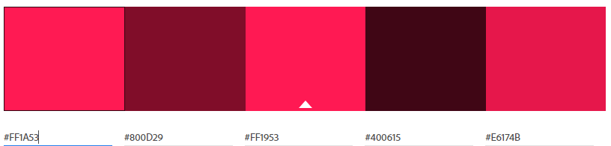

Testing/feedback: -

How will you use this feedback to improve the outcome?: -

## Design idea #2

Screenshot(s): -





<https://www.dafont.com/fipps.font>

<https://www.dafont.com/pixellari.font>

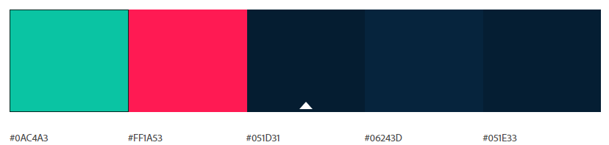

Testing/feedback: -

How will you use this feedback to improve the outcome?: -

## Design idea #3

Screenshot(s): -





<https://www.dafont.com/rainyhearts.font>

<https://www.dafont.com/alagard.font>

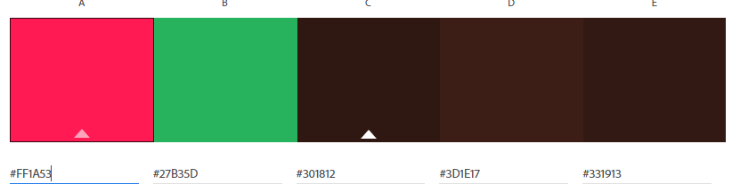

Testing/feedback: -

How will you use this feedback to improve the outcome?: -

# Iteration #2

Attach your website design images here. Alternatively, attach images to the appendix. Provide high-quality copies with the final submission.

## Design idea #1

Screenshot(s): -

Testing/feedback: -

How will you use this feedback to improve the outcome?: -

## Design idea #2

Screenshot(s): -

Testing/feedback: -

How will you use this feedback to improve the outcome?: -

## Design idea #3

Screenshot(s): -

Testing/feedback: -

How will you use this feedback to improve the outcome?: -

# Iteration #3

Attach your website design images here. Alternatively, attach images to the appendix. Provide high-quality copies with the final submission.

## Design idea #1

Screenshot(s): -

Testing/feedback: -

How will you use this feedback to improve the outcome?: -

## Design idea #2

Screenshot(s): -

Testing/feedback: -

How will you use this feedback to improve the outcome?: -

## Design idea #3

Screenshot(s): -

Testing/feedback: -

How will you use this feedback to improve the outcome?: -

# Explain the appropriateness of a chosen design

In addition to images of the design, explain in a few paragraphs why the one you have chosen is the most appropriate design out of your generated design ideas. Link your decision to:

* User experience methodologies
* Stakeholder feedback
* Usability testing

Screenshot(s): -

I have selected this design because: -

## Evaluate how user experience methodologies were used in developing the chosen design

-

# Evaluate how the design addresses relevant implications

How does your chosen design **address** relevant implications?

## Social

-

## Cultural

-

## Legal

-

## Ethical

-

## Intellectual property

-

## Privacy

-

## Accessibility

-

## Usability

-

## Functionality

-

## Aesthetics

-

## Sustainability and future proofing

-

## End-user requirements

-

## Health and safety

-

# Justify that the chosen design is suitable for the purpose and end users

-

# Justify how the chosen design might be further developed in the future

-

# Appendix

If you would prefer to place images here rather than in each section, add a hyperlink in each section to the relevant image. This makes the document easier to navigate.

**DELETE THESE INSTRUCTIONS BEFORE YOUR FINAL SUBMISSION.**

To add an image to this section, follow these steps:

1. Add a new paragraph with the Heading 2 style (green text, underline across page). This is the title of the image. *Make sure the name is meaningful on its own. For instance, “Website design 1 homepage” or “Entity Relationship Diagram”*
2. Press Enter to move to a new line.
3. Attach the image beneath the heading.
4. Back in the relevant document section:
   1. Select some text to serve as a link.
   2. Right-click on the text, hover over the arrow next to Link. At the bottom of the list, click Insert Link.
   3. On the left, click on Place In This Document.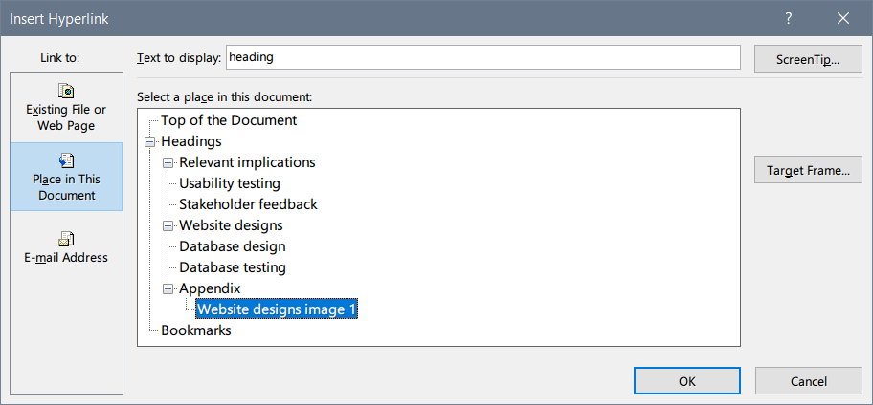
   4. Under Appendix, choose the heading you have just created and click OK.

## Example image: website designs image 1

Here is an example of a hyperlinked image. A link to it is included in the Website designs section. **DELETE THIS IMAGE BEFORE YOUR FINAL SUBMISSION**.

